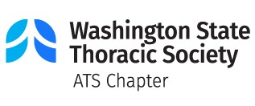
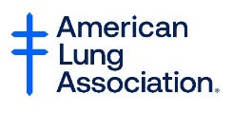
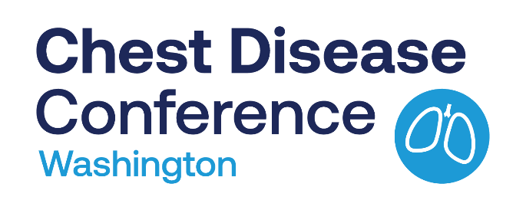
Join us for the 34th Annual Chest Disease Conference!

January 19-21, 2024
Leavenworth, WA or virtual
The Annual Chest Disease Conference is a continuing medical education conference provided by the Washington Thoracic Society and American Lung Association in Washington. The program is designed to cover a broad spectrum of clinical pulmonary and critical care topics. Participants learn about the principles of diagnosis and treatment of common and unusual conditions for which recent new management strategies are available.

Who Should Attend
This annual conference is geared towards physicians and allied health professionals in pulmonary, critical care, and sleep medicine, thoracic surgery, allergy, infectious disease, family practice and internal medicine.

Accreditation
The American Thoracic Society designates this live activity for a maximum of 10 AMA PRA Category 1 Credits™. Application for Continuing Respiratory Care Education credit has been submitted to the American Association for Respiratory Care.

Conference Format
The conference will be offered in a hybrid format, combining in-person conference experience with a virtual component. The live event will be held in Leavenworth, WA.

Educational Sessions
Featured Sessions and Speakers:
George A. Brooks, PhD
University of California, Berkeley

- “Muscle and Whole-Body Lactate Kinetics: Organ-Organ, Cell-Cell, Intracellular, and Postprandial Lactate Shuttles”

Gehan Devendra, MD
University of Hawaii & The Queen’s Medical Center

- “Multidisciplinary Approach to Pulmonary Hypertension Care”

Plus, updates to the new PFT standards and interpretation, multidisciplinary approaches for care for COPD and PH, pulmonary rehabilitation, provider burnout, and health inequity in pulmonary and critical care locally & in Hawaii.

Register at www.WashingtonThoracic.org
This conference is sponsored by the American Thoracic Society, the Washington Thoracic Society and the American Lung Association in Washington.

